**An Android Dev Project Report**

**On**

**Quotes App Using Kotlin**

**In**

**Android Studio**

**Submitted By : Megha Raj**

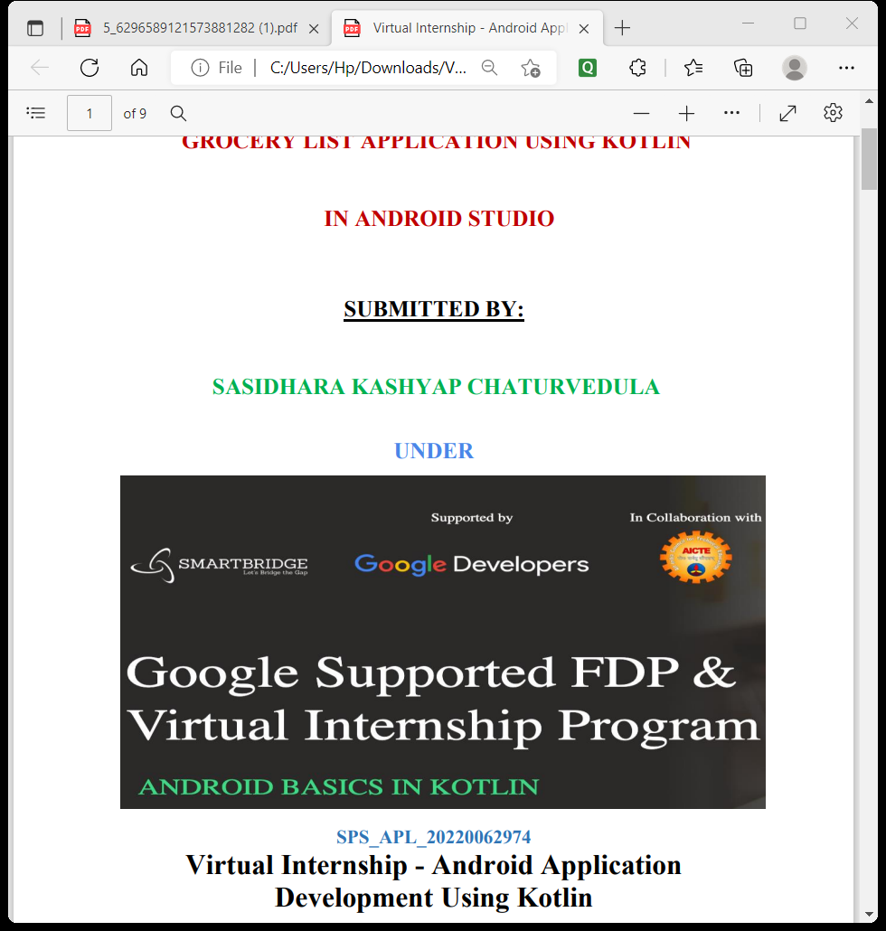

**==========SPS_APL_20220070961**==========

Virtual Internship

Android Application Development Using Kotlin

INDEX

1. INTRODUCTION
   1. Overview
   2. Purpose
2. LITERATURE SURVEY
   1. Existing Problem
   2. Proposed Solution
3. THEORITICAL ANAYSIS
   1. UI
   2. Hardware/Software Designing

4.FLOWCHART

4.1 View Model

4.2 Lifecycle of View Model

4.3 Step by Step Process

5.IMPLEMETATION & DESIGNING

5.1 VIEWMODEL

5.2 VIEWMODEL FACTORY

6. CONCLUSION & FUTURE SCOPE

7.APPENDIX

**QUOTIFY**

1.INTRODUCTION

* 1. OVERVIEW

>>This app is nothing but an mind refreshing app to keep up the moral. This app can be used by children for daily morning thought.

As we all know in today’s being able to cope up with the world is much difficult as there is much difficulties by every day negative environment and this app helps a lot with quotes.

If every day we read one quotes then this may help us in being positive and shining like a star.

There are quotes by many famous successful people as well as scientist and inventors.

We can use that quotes on our story as well as on about in WhatsApp.

This app can be used on any virtual device without internet.

1.2 PURPOSE

>> The main aim of this app to give positive vibes to the people whose ever moral is down and making people more energetic and passionate about their work because now-a-days peoples are more negative than dreaming for success.

2. LITERATURE SURVEY

2.1 EXISTING PROBLEM

>> There is an existing problem as there is no app to motivate people but always an demotivating apps.

As there are more apps which are useless but this app will help a lot to people in being positive always.

2.2 PROPOSED SOLUTION

>> Solution is nothing but an app with only positive vibes with sharing option as well so, that people around be also positive because positivity surrounding can only leads to high moral.

It will helps a lot to children for morning thoughts for which they have to google every time through this app they can find it on one place. Being positive is much important in today’s life as negativity leads to only bad energy and depressed like environment.

There are many suicide cases now-a-days because many reasons but being demotivated is one very big reason and not accepting life as it is and through quotes reading habit they can try to approach life with different prospective.

3.THEORITICAL ANALYSIS

3.1 UI

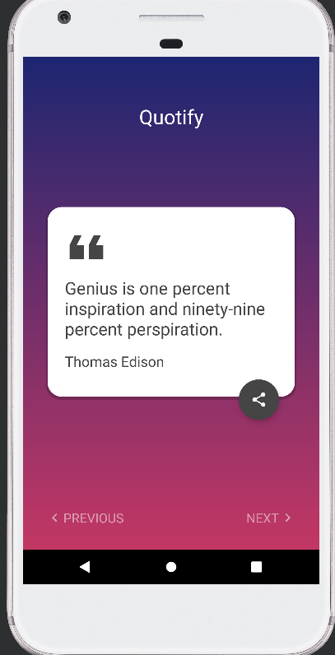3.3 HARDWARE/SOFTWARE DESIGN

HARDWARE

* + - * RAM – 16GB
      * ROM – 128GB

SOFTWARE

>> The Software Package is developed using Kotlin and Android Studio, basic JSON to store Quotes.

* + - * WINDOW 11
      * ANDROID STUDIO – DOLPHIN 2020-21
      * LANGUAGE – KOTLIN
      * EMULATOR -PIXEL XL API 33

4.FLOWCHART

4.1This app is made through view model and json.

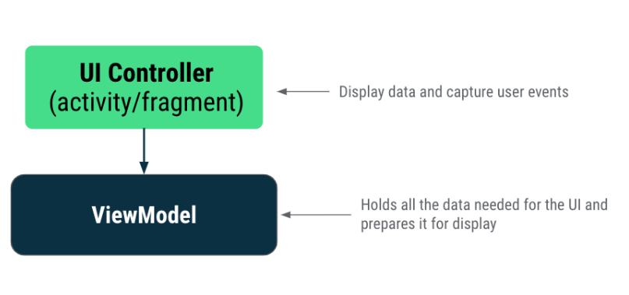

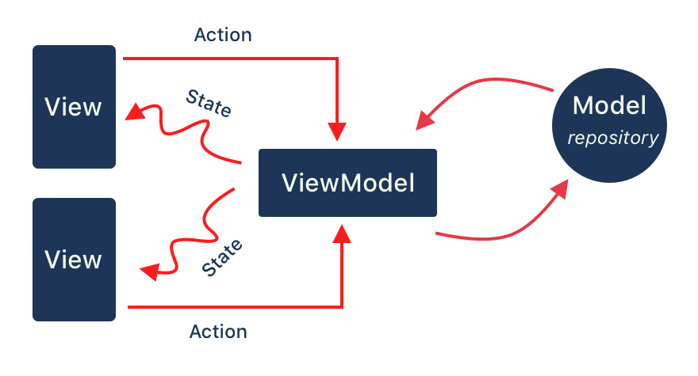

4.2 Lifecycle of View Model

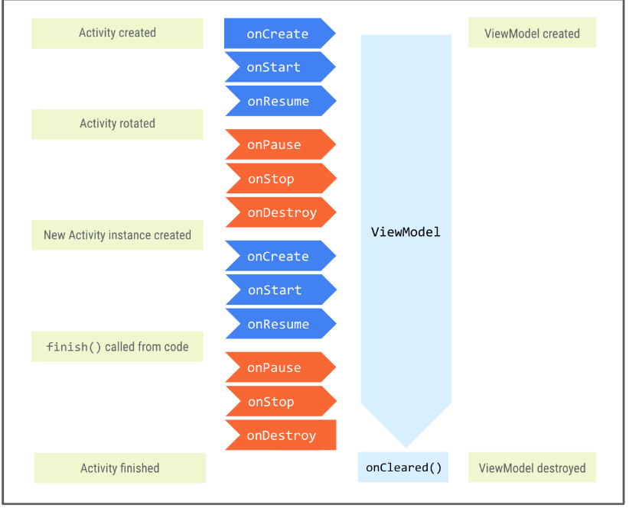

4.3Step By Step Process

Step 1: Create a New Project To create a new project in Android Studio please refer to How to Create/Start a New Project in Android Studio. Note that select Kotlin as the programming language.

Step 2: Before going to the coding section first you have to do some pre-task

Before going to the coding part first add these libraries in your gradle file and also apply the plugin as ‘kotlin-android’. To add these library go to Gradle Scripts > build. Gradle (Module: app).

Step 3: Architectural Components

>> ViewModel Class ViewModel class used as an interface between View and Data. Quotify View Model class inherit from View Model class and stored in repository variable. As we pass the constructor in View Model we have to create another class which is a Factory View Model class. Go to app > java > com.example.application-name > UI. Right-click on the UI package and create a Kotlin file/class and name the file as MainViewModel.

>> FactoryViewModel Class We will inherit the Main ViewModel Factory class from ViewModelProvider.

6. CONCLUSION & FUTURE SCOPE

This is an app with positive vibes to keep people chill and relaxed be motivated by quotes.

>>Future Scope of this project is that in future this app name will be changed and includes many features like yoga videos, motivational speaker videos and also an calling feature to cope up peoples.

7. APPENDIX

Source code on my GitHub profile

Link - https://github.com/m5gh1/quotes

Google Developer

Link - https://developers.google.com/profile/u/113439834563792611405

>>At last I would like to thanks google and smart bridge for this wonderful opportunity.